**Module and include controller:**

First record the test to performs in a page.

We can record the script using blaze meter and download the recording.

It will shows in the download open in the JMeter.

Add the sampler to the Thread,and paste divide the recording tests in that as required.

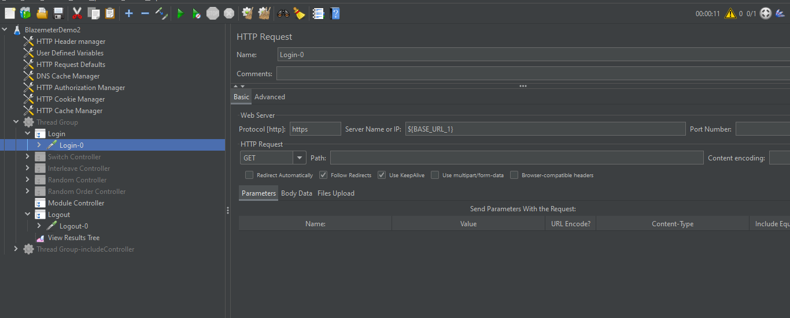

By using the module controller we can run the disabled test and run.

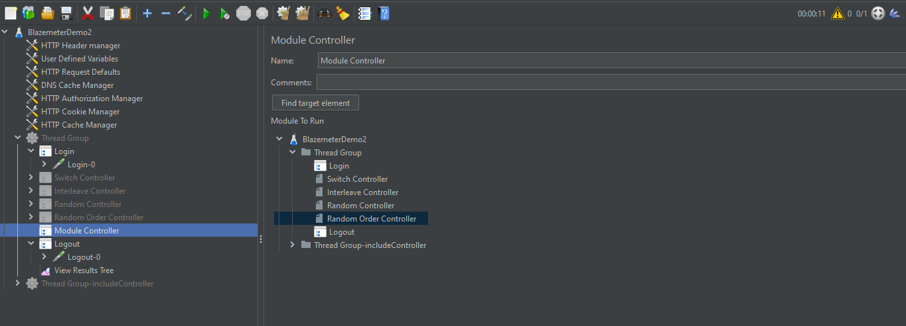

As we can see that above I selected the random order controller ,and can see the result .

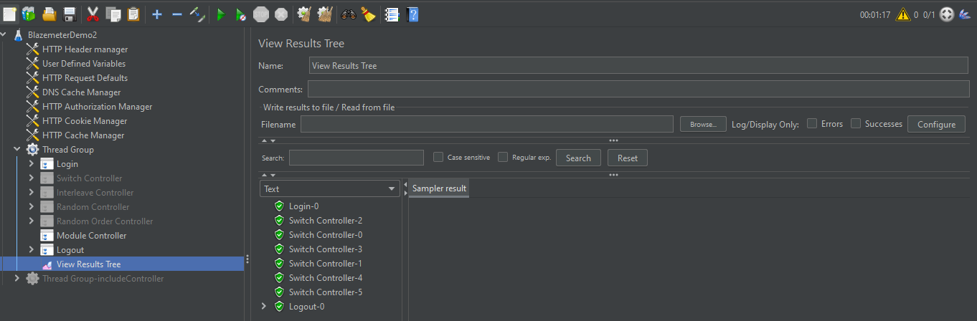

**Include controller:**

**First I created the separate test add test fragment for that add HTTP Request.**

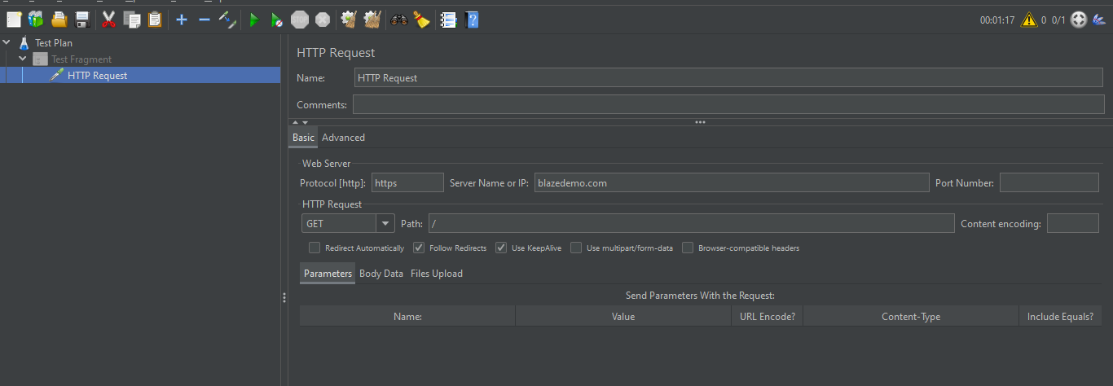

Thread-right click-add-controller-include controller.

Browse the location of that above file path and give in include controller.

